**NAME :** S SIVA PRASAD

**BATCH :** 126

**MOBILE NO :** 6303246170

**ASSIGNMENT**

**CREATE THREE INSTANCES, INSTALL NGINX, AND APPLY APPLICATION LOAD BALANCER.**

**Create a three-instances**

**EC2 INSTANCE:** These are just the virtual machines in the cloud on which you have the OS level control. You can run whatever you want in them.

Launching instances with existing security groups.

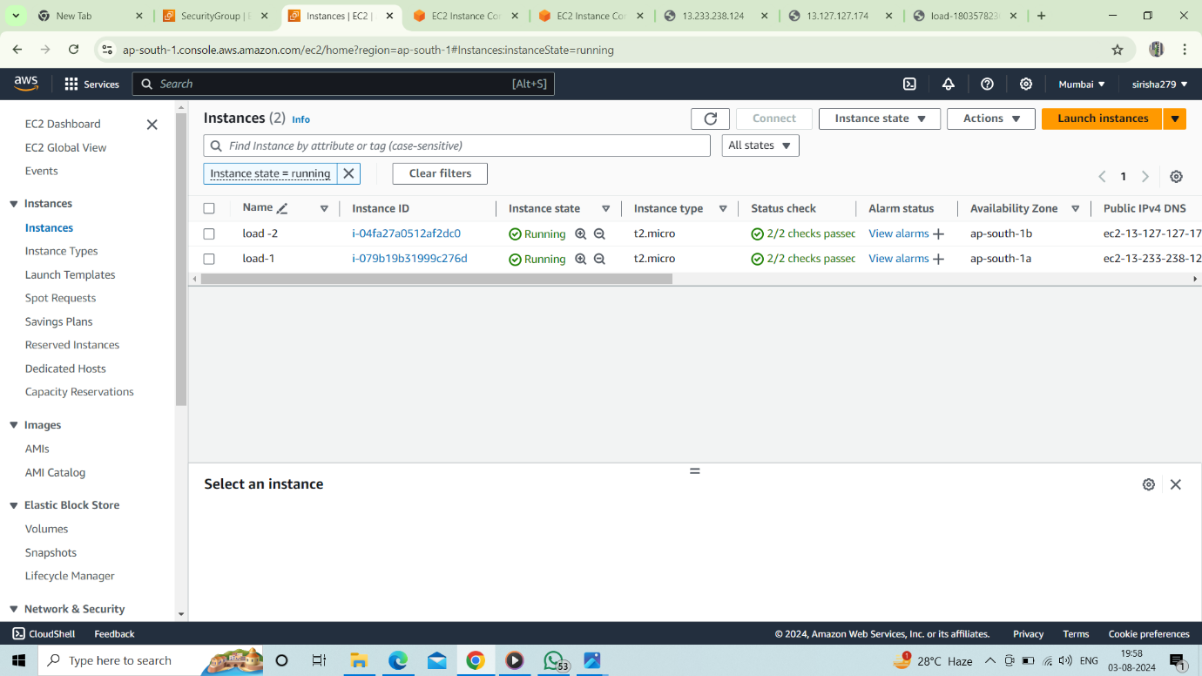

**INSTALLING NGINX IN THE SERVER:**

**NGINX:** It is a web server that can also be used as a reverse proxy, load balancer, mail proxy, and HTTP cache.

**Step 1:** Log in to the server using the ec2 instance. After signing in type “**sudo -i”** to become the root user.

**Step 2:** Run the below commands to install **“nginx”** on the server.

1. **“yum update -y”** – To check any updates and install updates

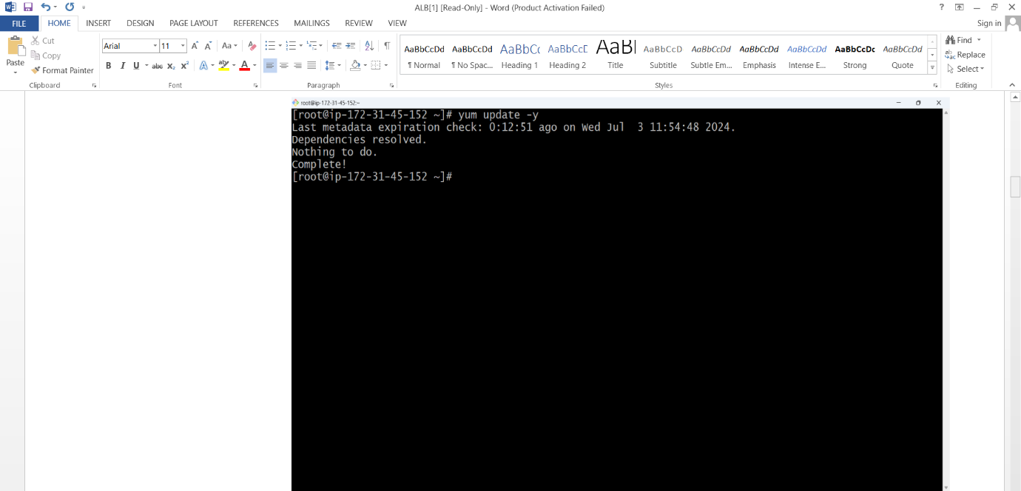

1. **“yum install nginx -y”** – To install nginx web browser on the server.

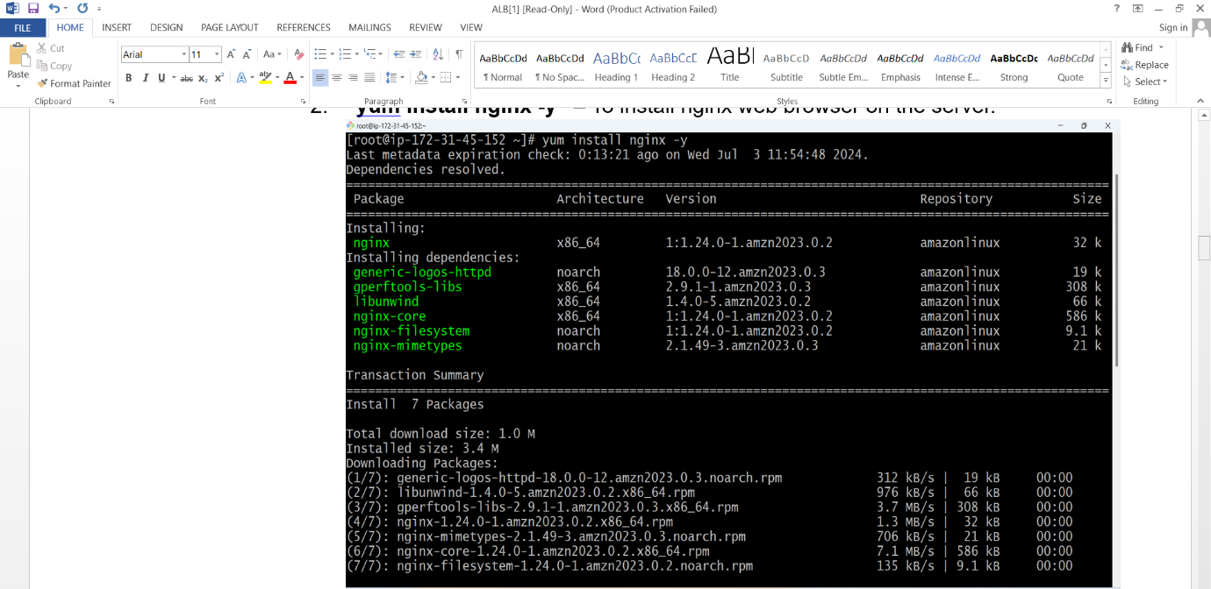

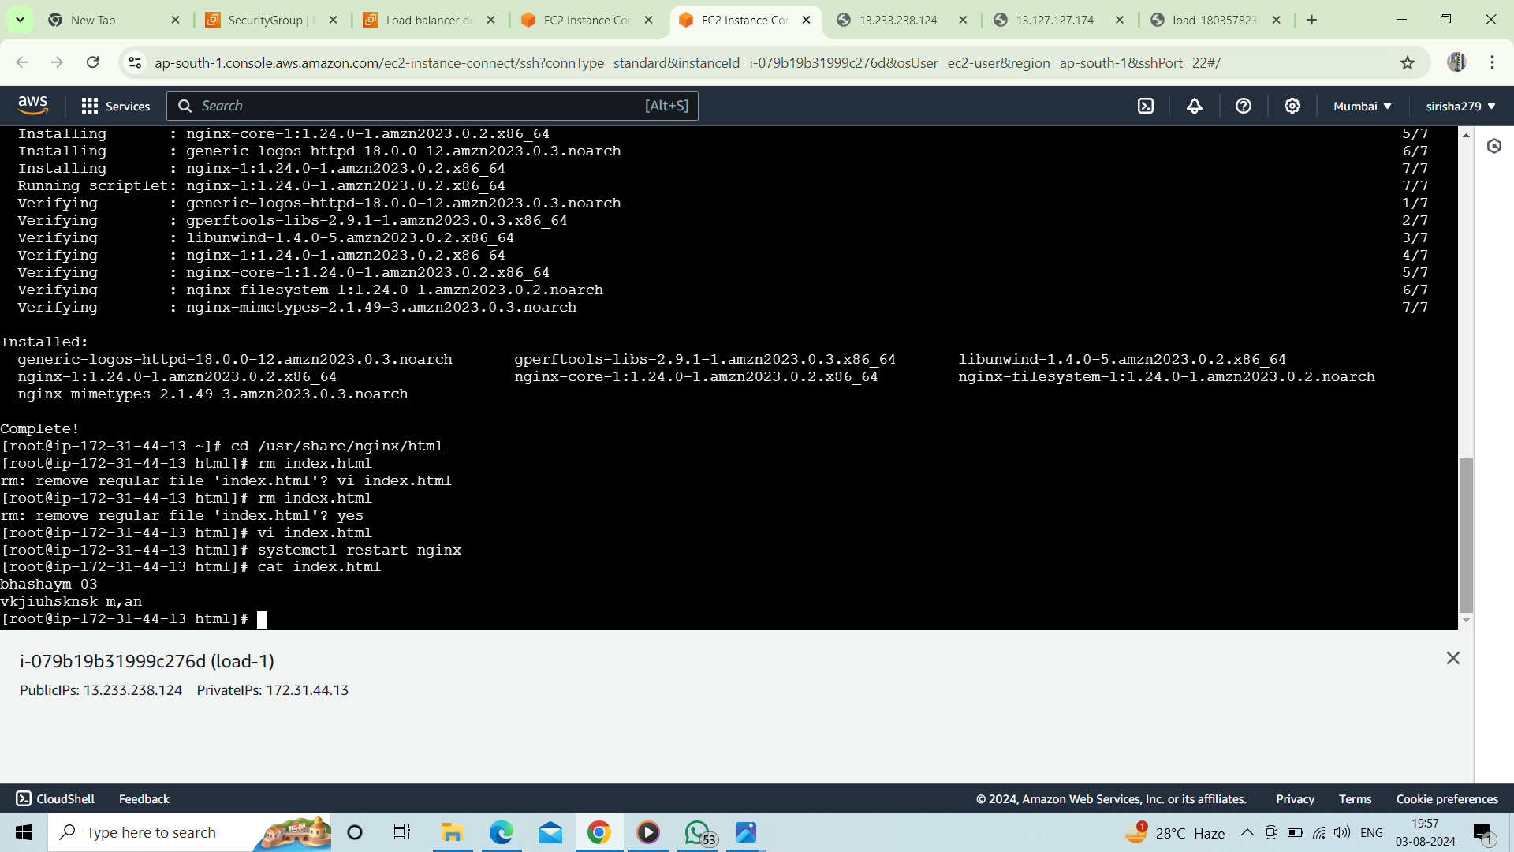

1. “**cd /usr/share/nginx/html”** – This allows you to see the HTML file of nginx.
2. “**rm -rf index.html”** – This will remove the index.html file recursively and forcefully.
3. “**vi index.html”** – Creates a file of index.html with content you add in that file.
4. “**systemctl restart nginx”** – This command will restart the nginx browser
5. **“systemctl status nginx”** – This command allows you to see the status of the browser.
6. Copy the public of a particular instance and paste it with “**:80”** to see the content of the index.html file on the web browser.



These steps are common for the remaining two ec2 instances.

**APPLICATION LOAD BALANCER AND CONNECTION WITH RESOURCES.**

**Creating Target Group.**

**Target Group:** A Target group is used to route requests to one or more registered targets.

**Step 1:** Click on Create target group.

**Step 2:** Specify group details by providing the target group name, protocol port, IP address type, and protocol version.

**Step 3:** Register targets by connecting three available ec2 instances and also click on “include as pending below”.

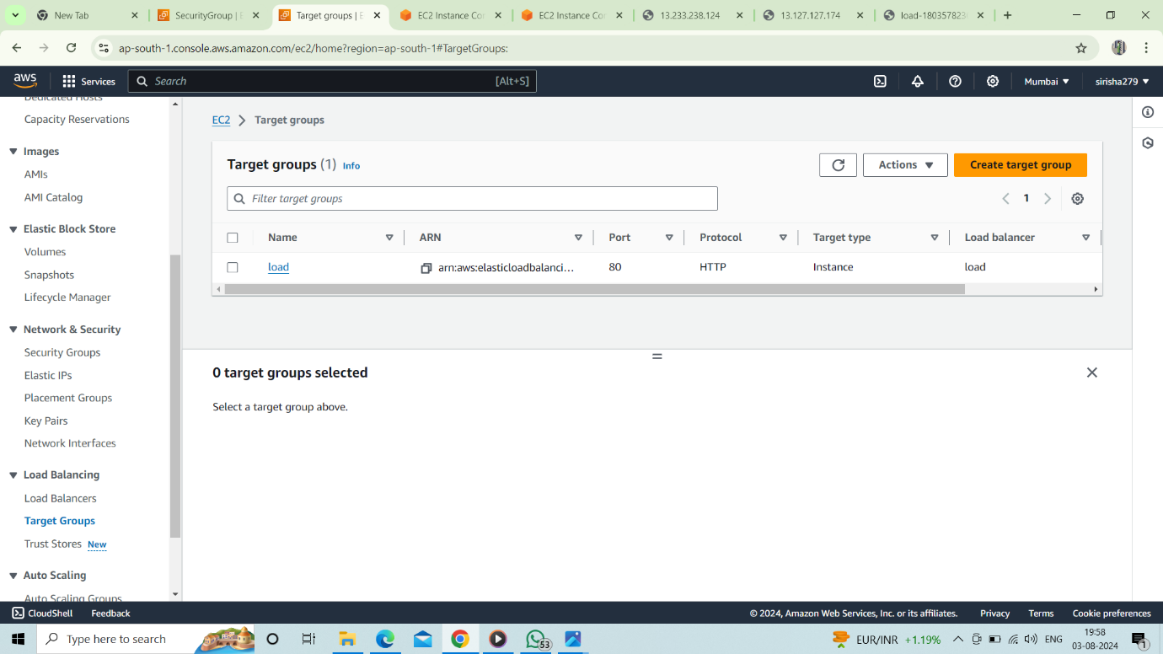

**Creating a Load balancer and attaching it to the Target group.**

**Load Balancer:** Load balancing is the method of distributing network traffic equally across a pool of resources that support an application.

**Step 1:** Select Create Application Load Balancer

**Step 2:** Specify the basic configuration by specifying the load balancer name, scheme, IP address, and network mapping(select three mappings shown on the device), attach the security group created, and in listeners and routing attach the target group and click on create load balancer.

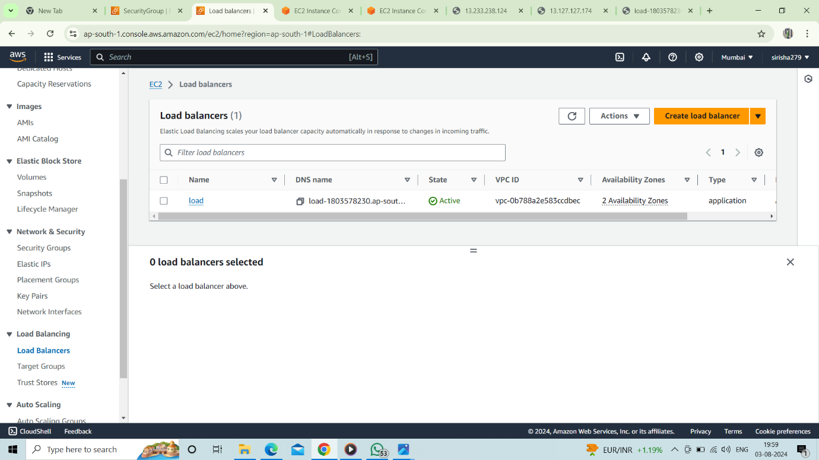

**Step 3:** Copy DNS(Domain Name System) and paste it on browser.

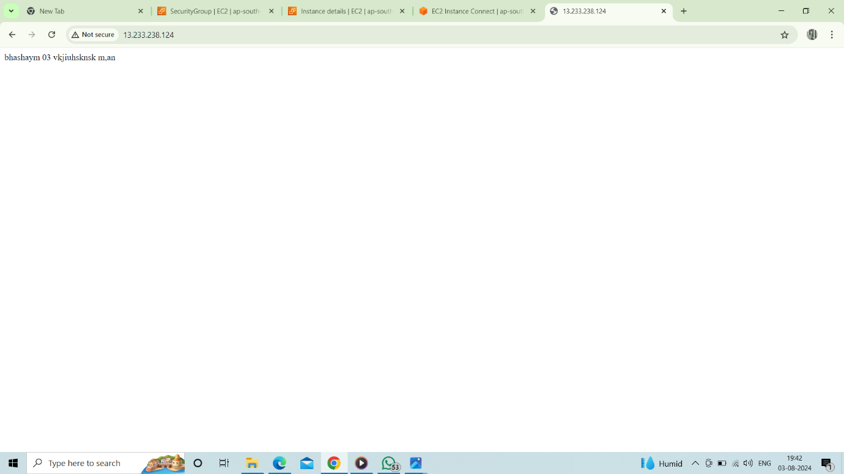

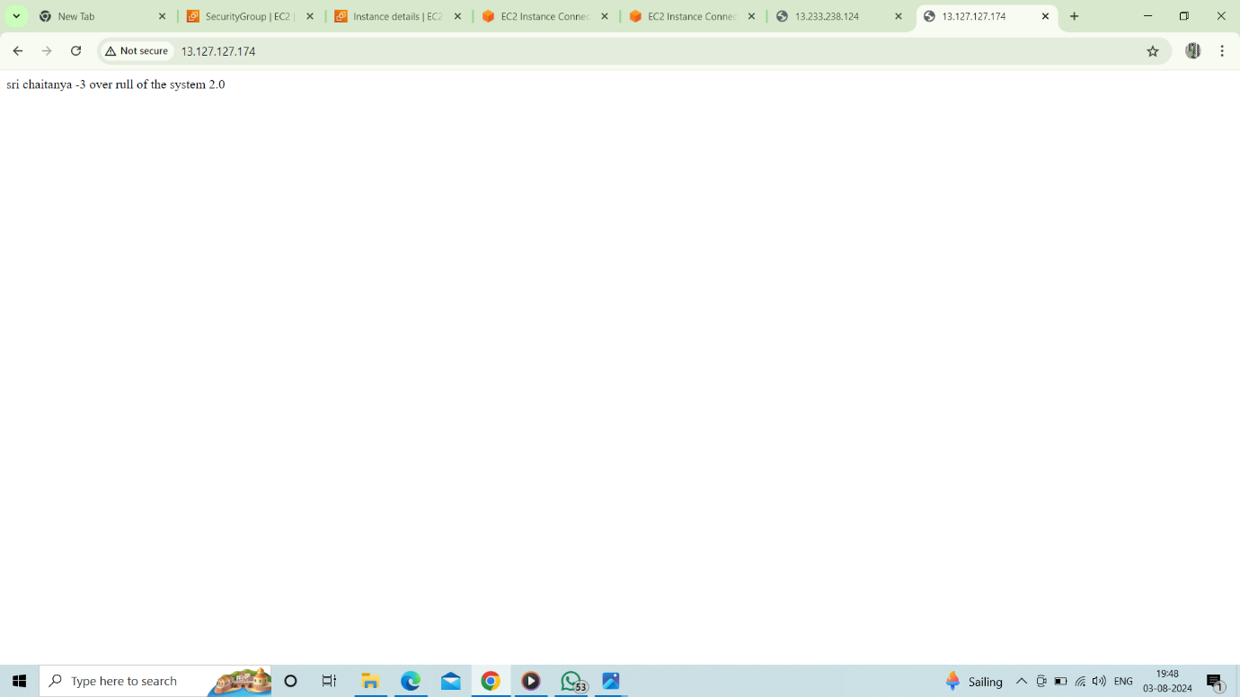

Due to some security reasons, we are getting some server errors. Otherwise, every time we refresh the browser, we see the content of each index.html file of three instances, which balances their load on the server.